**Project Design Phase-II**

**Data Flow Diagram & User Stories**

|  |  |
| --- | --- |
| Date | 28 June 2025 |
| Team ID | LTVIP2025TMID40768 |
| Project Name | Traffictelligence |
| Maximum Marks | 4 Marks |

**Data Flow Diagrams:**

A Data Flow Diagram (DFD) is a traditional visual representation of the information flows within a system. A neat and clear DFD can depict the right amount of the system requirement graphically. It shows how data enters and leaves the system, what changes the information, and where data is stored.

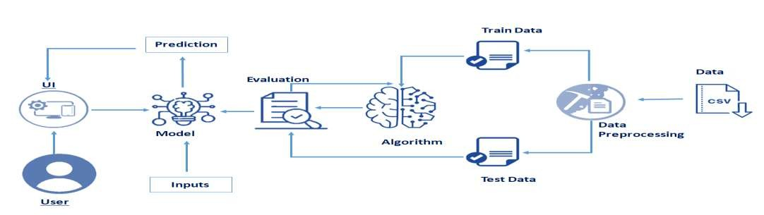

**User Stories**

Use the below template to list all the user stories for the product.

|  |  |  |  |  |  |  |
| --- | --- | --- | --- | --- | --- | --- |
| **User Type** | **Functional**  **Requirement**  **(Epic)** | **User Story**  **Number** | **User Story / Task** | **Acceptance criteria** | **Priority** | **Release** |
| Urban  Commuter  (Web) | Traffic Volume Prediction  Error Handling | USN-1 | As a commuter, I can input weather and time data to get traffic predictions. | Prediction displays within  2 seconds | High | Sprint-1 |
| Traffic  Manager(Web) | Traffic Volume  Prediction | USN-2 | As a manager, I can view traffic predictions for planning. | Prediction matches expected range. | High | Sprint-1 |
| Delivery Driver  (Web) | Navigation | USN-3 | As a driver, I can return to the input page from results. | Back link works and reloads form | Low | Sprint-2 |
| Administrator  (Web) | Maintenance | USN-4 | As an admin, I can update the model with new data | Model reloads without errors. | Medium | Sprint-1 |